**Accounts info:**

Gateway of tally holds many features and Account Info is one of them through which we can provide Tally the details of our company’s account, which are Groups, Ledger and Voucher.

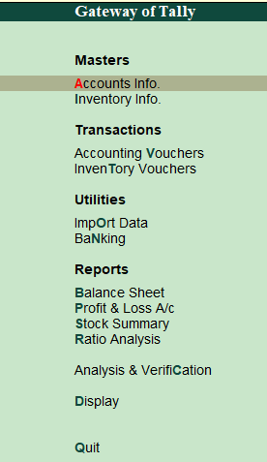

**Group**

The group is a collection of leaders of the same nature. Tally software automatically creates 28 groups that are used in the account chart.

**Creating single group** 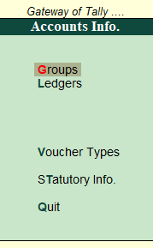

To create a single group, we have to go to tally and then click on the group. In the group, we click on a single group and then create.



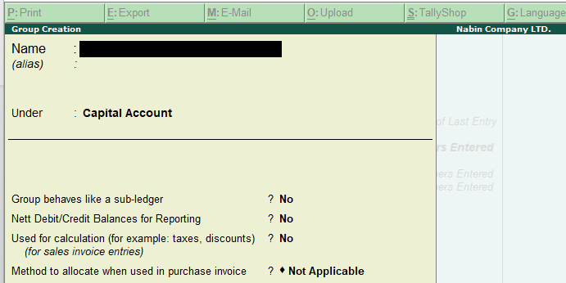

**Displaying of single group**

To display a single group, we have to go to tally and then click on the group. In the group, we click on a single group and then display.

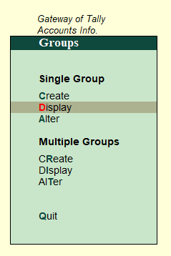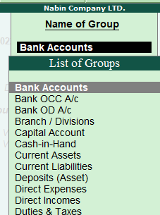

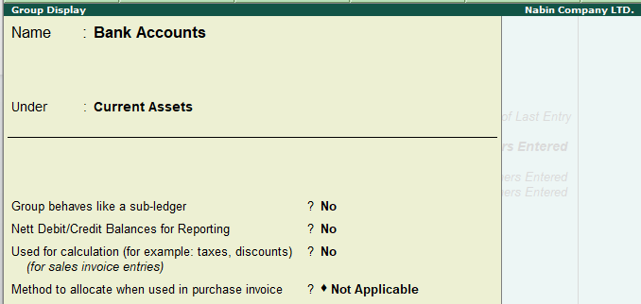

**Alteration of a single group**

We can simply alter the single group click on alter option available on a single group.

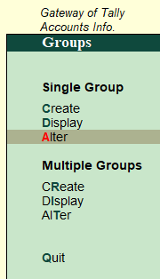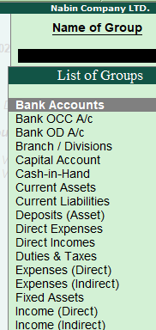

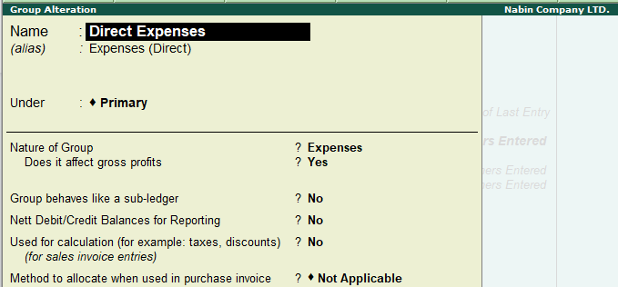

**Creating multiple groups**

click on multiple groups then click on create. After that fill in the detail and press enter.

.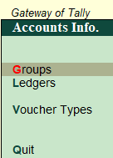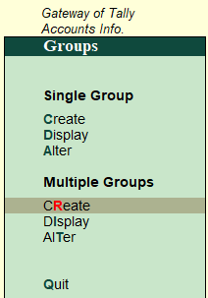

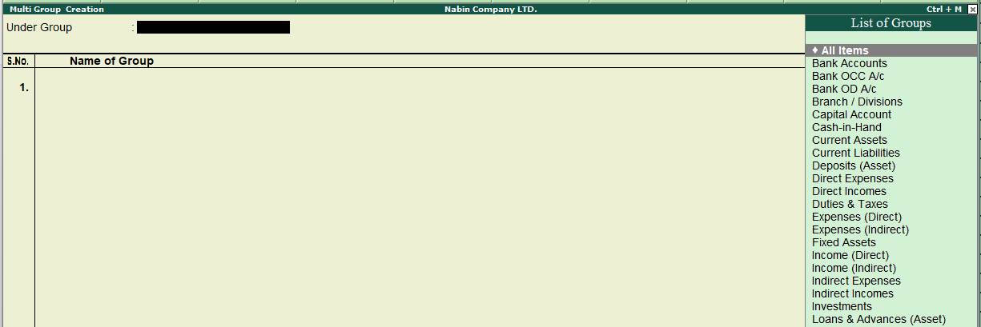

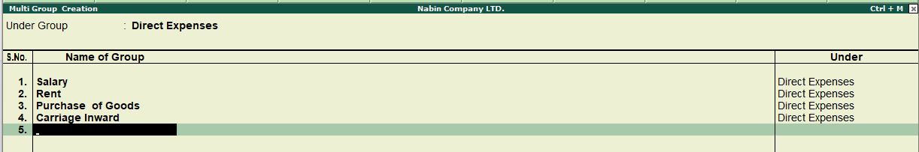

**Displaying multiple groups**

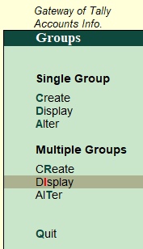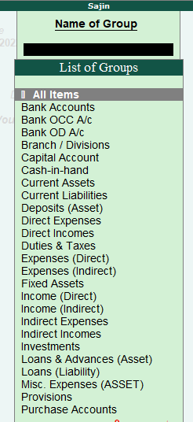

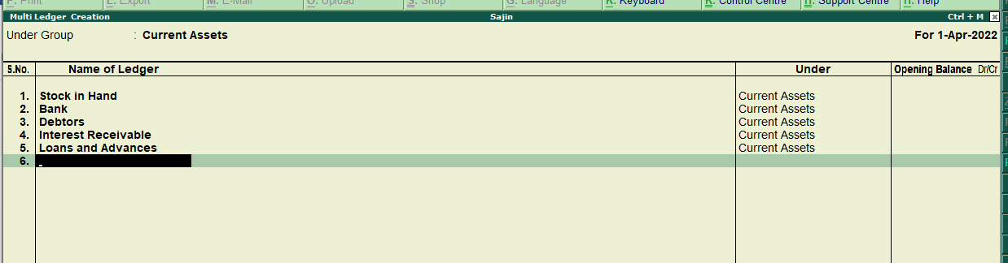

**Alteration of multiple groups**

We can alter multiple groups by clicking on alter option available on multiple groups.

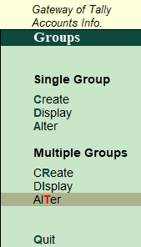 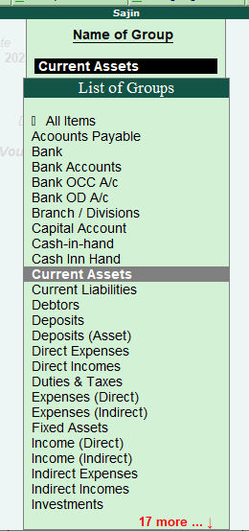

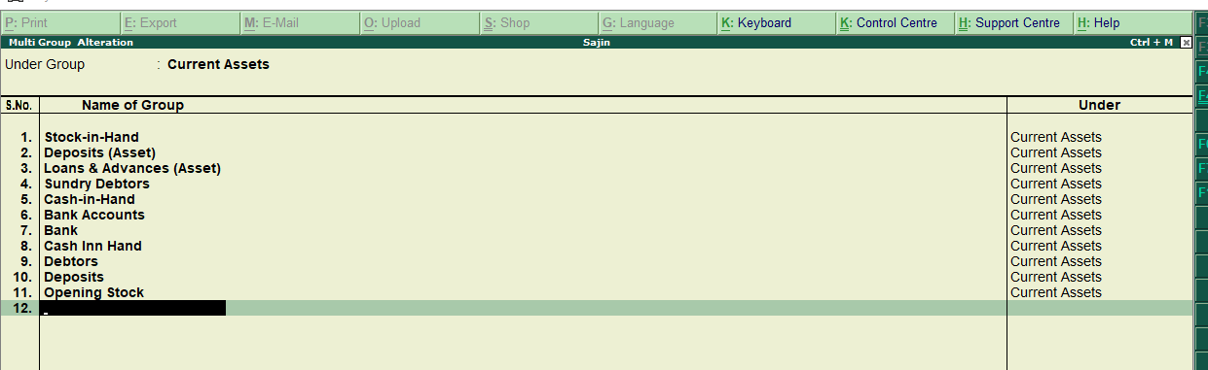

**Ledger**

The statement or book that records the transactions in one place to a particular subject to help determine the net result is known as a ledger. Ledger is the actual account head to identify your transactions and is used in all accounting vouchers. Ledger journal entries include accounts like cash, purchase, sales, investments, inventory, and other account heads. Without a ledger, it is difficult to record transactions. All ledgers have to be classified into groups.

**Ledger Creation**

**Single ledger Creation**

In tally by creating a single ledger, we can create individual ledgers at a time. To create a ledger we have to create a ledger each time

Steps

* Go to the gateway of tally
* Go to account info
* Click on the ledger
* Create a single ledger

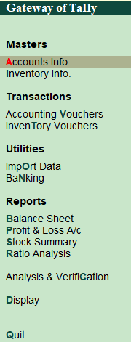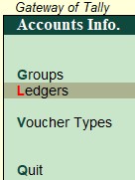

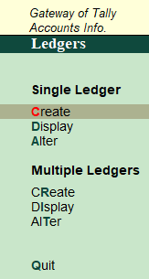

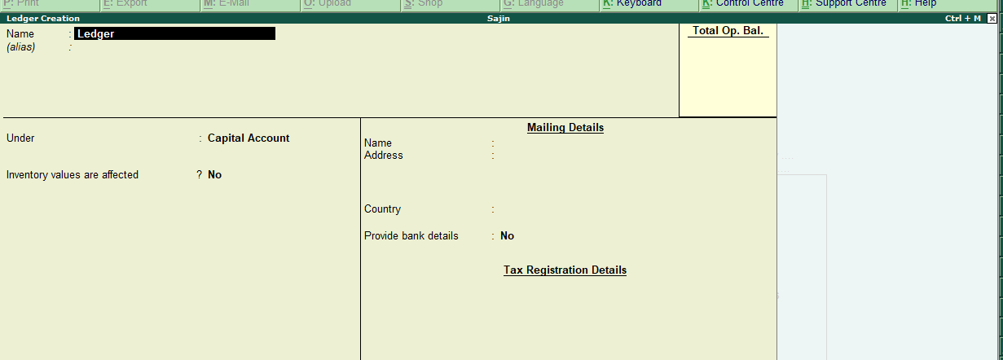

**Display single ledger**

To display a single ledger, the following steps are followed:-

Gateway of tally > account info> ledger > single ledger> display

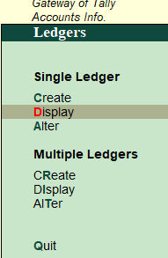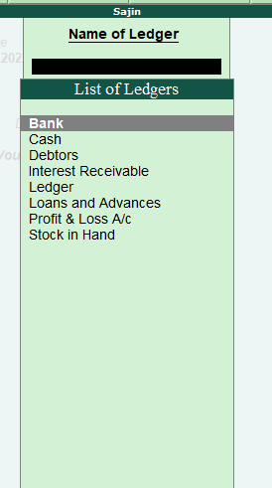

After that click on the one ledger to one ledger among the list to view the detail.



**Alter ledger**

Alter feature is used to change the name of the ledger head, and transaction, and can delete the ledger.

**Alternation of single ledger**

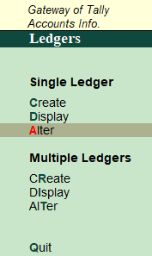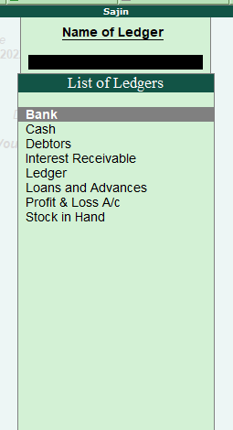

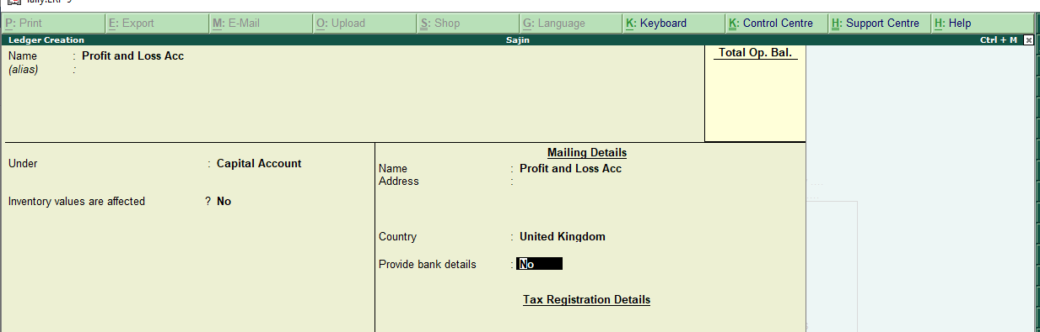

**Multiple ledger Creation**

In multiple ledger, we can create multiple ledgers under the same group at a time.

Steps

* Go to the gateway of tally
* Go to account info
* Click on the ledger
* Create multiple ledgers

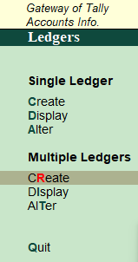



**Display multiple ledgers**

To display a single ledger, the following steps are followed:-Gateway of tally > account info> ledger > multiple ledgers > display

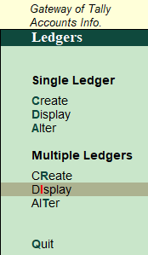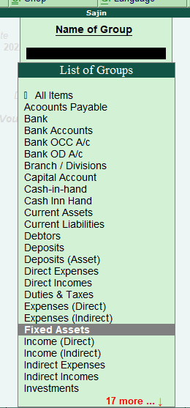

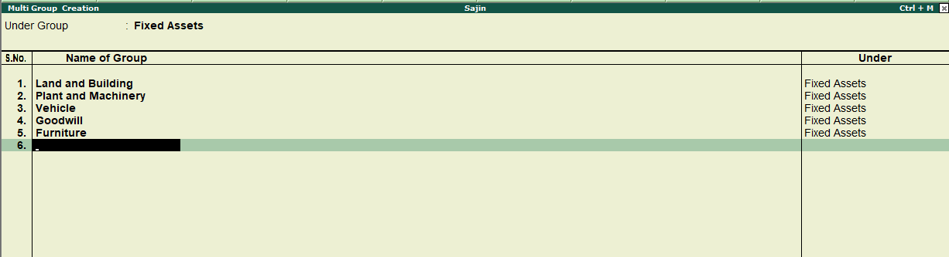

**Alter ledger**

Alter feature is used to change the name of the ledger head, and transaction, and can delete the ledger.

**Alternation of multiple ledgers**

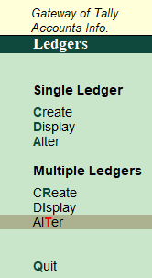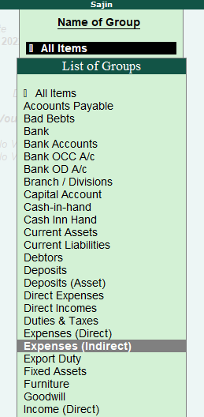

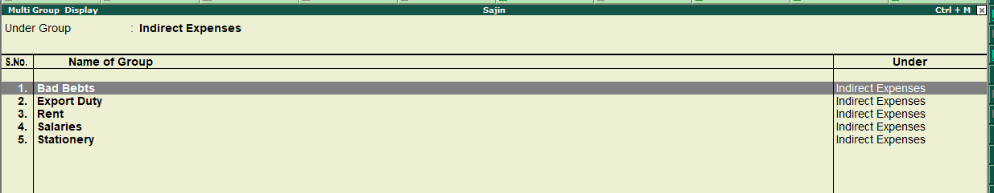

Multiple ledgers and single ledger alteration are the same but the difference is in multiple alterations we can alter multiple ledgers.

**Posting in ledger**

When we click on create in multiple ledgers we can choose the group and start to post different accounts in respective accounts heads.

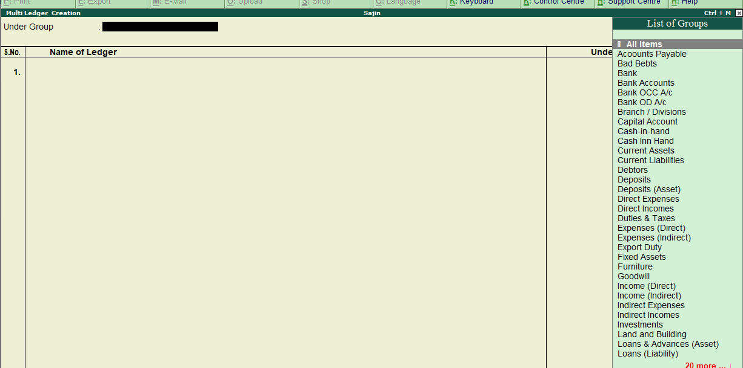 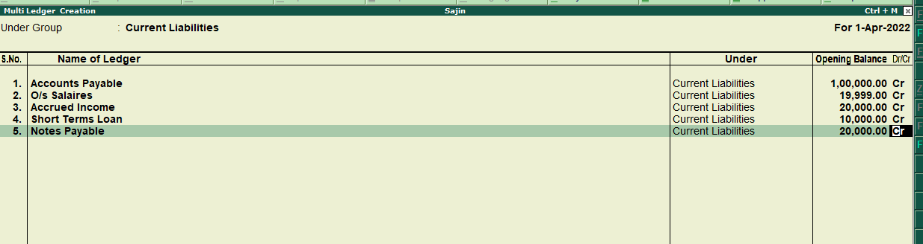

**Trial balance**

after recording the transaction in journals, ledger, or in a subsidiary book it is necessary to verify whether all the entries in the book of the accounts are correctly made. For this, a list of debit and credit totals or balances of all ledger accounts is prepared on a particular date called a ‘Trial Balance’. It includes asset, liability, equity, revenue, expense, gain, and loss account. The trial balance is run as part of the month-end closing process.

To open the trial balance in tally click on the display option on the gateway of tally and then click on the trial balance.

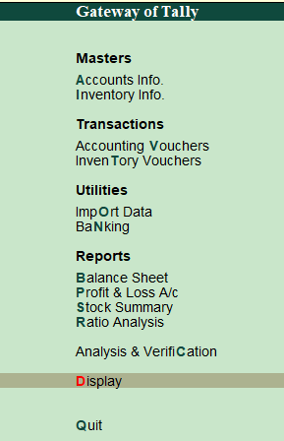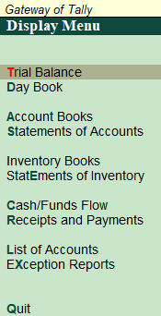

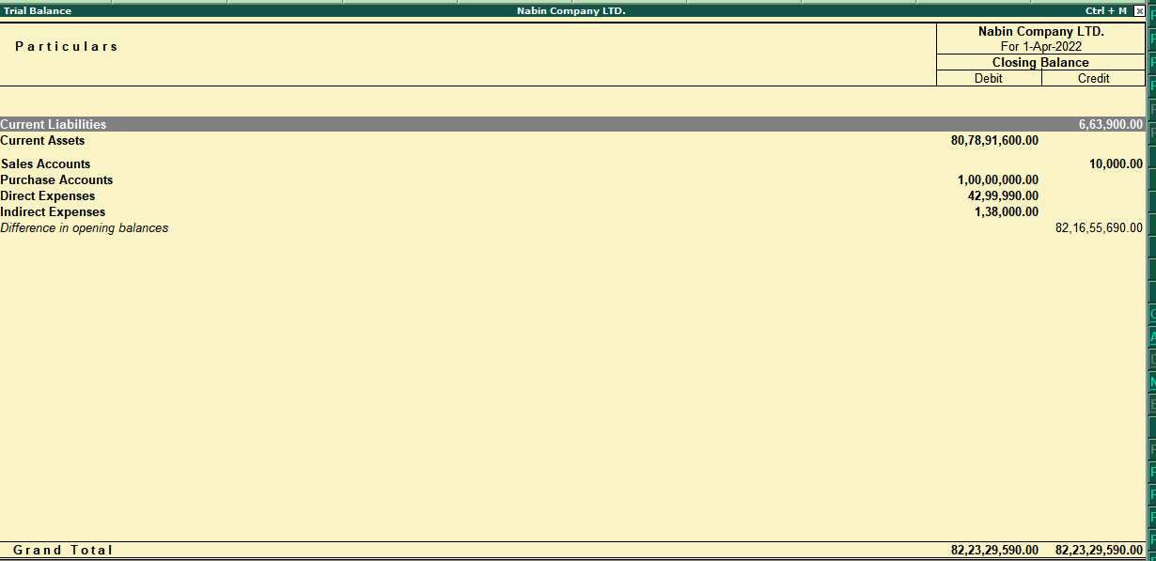

**Trading account**

A trading account is an account that is prepared for ascertaining the overall result of trading i.e. buying and selling of goods. It is an investment account. It is used to determine gross loss or gross profit.

**ledger posting on the trading account**

ledger posting of treading account on debit side

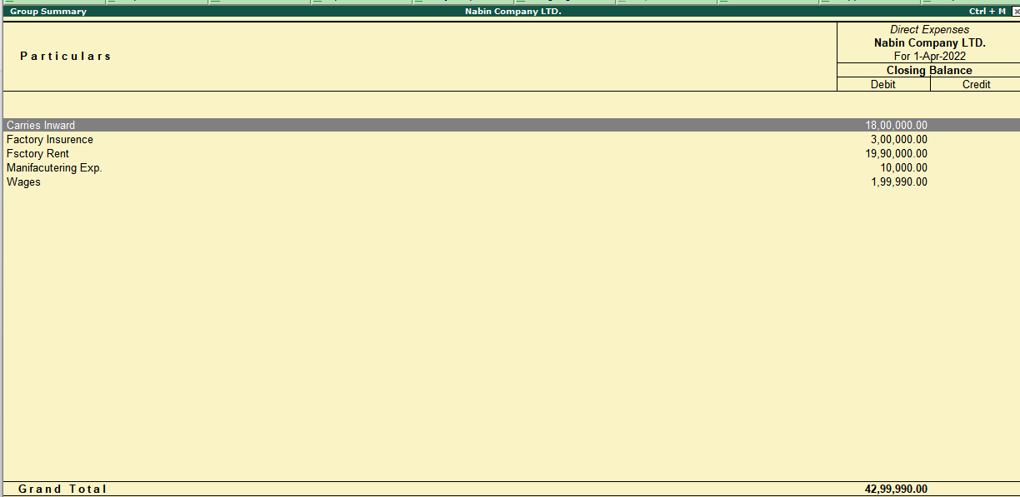

Ledger posting of trading account on credit side

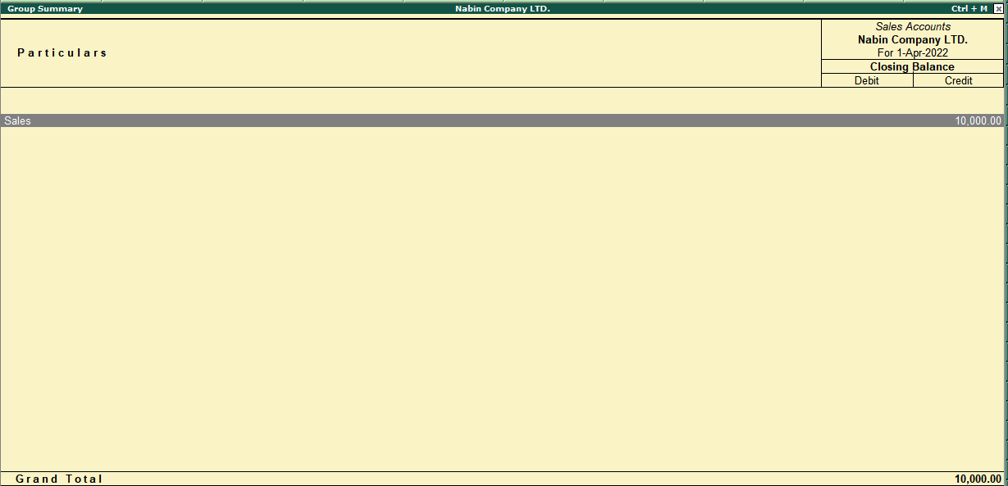

**Profit and loss account (P/L)**

A profit and loss account is a nominal account having debit and credit sides. Only indirect expenses, indirect incomes, or indirect revenues are considered in it. It is prepared to find net loss and net profit.

Posting in debit side

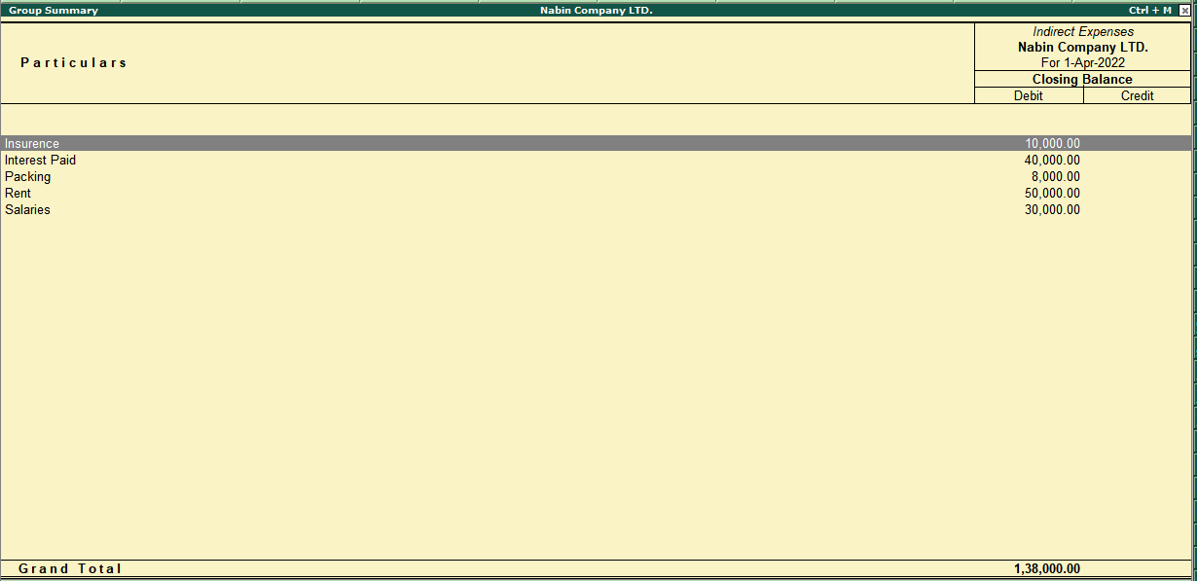

Posting in credit side

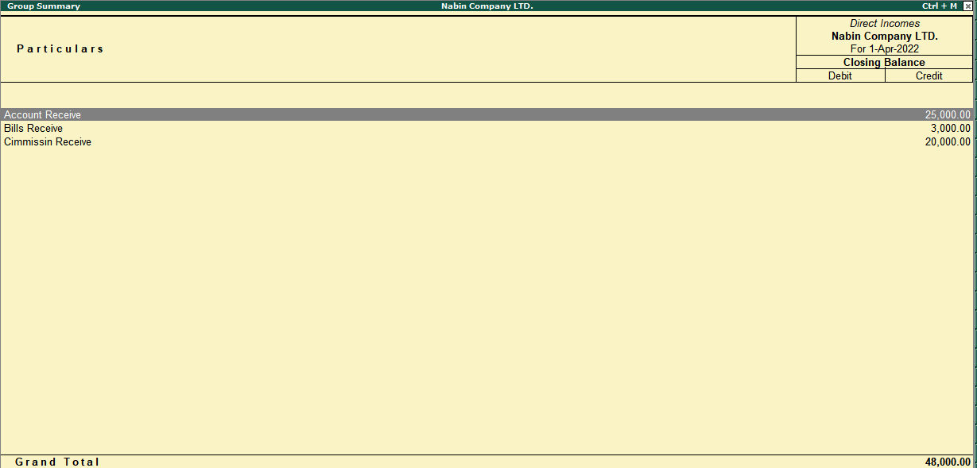

We can open the profit and loss account by clicking on profit and loss A/c in the gateway of Tally.

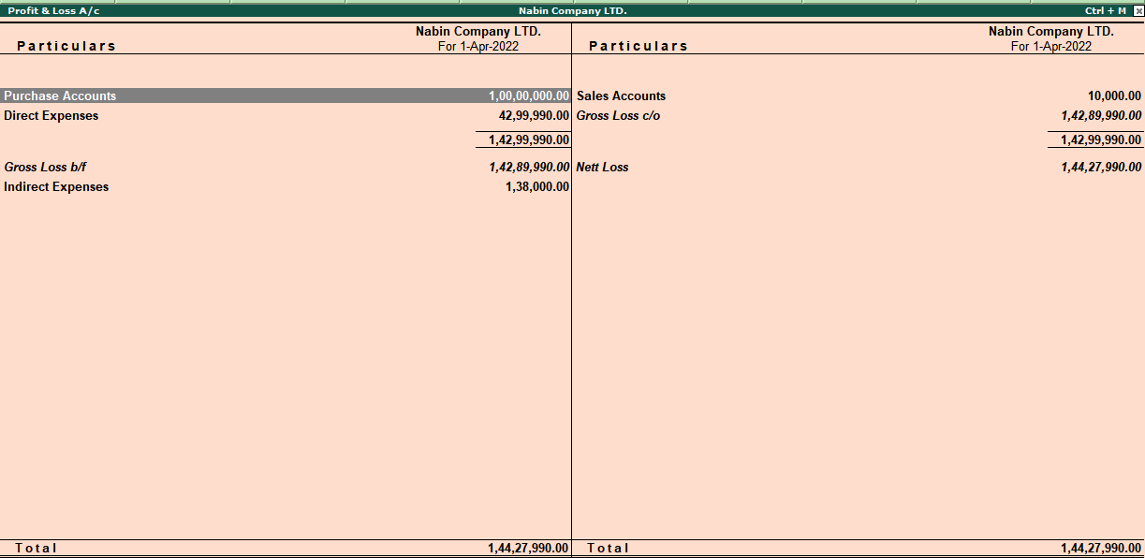 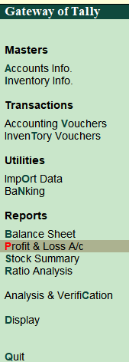

**Balance sheet**

A balance sheet is a financial statement that reports a company's financial position. This report shows the balance between the assets and liabilities of a firm.

Posting on the balance sheet

Posting on the assets side

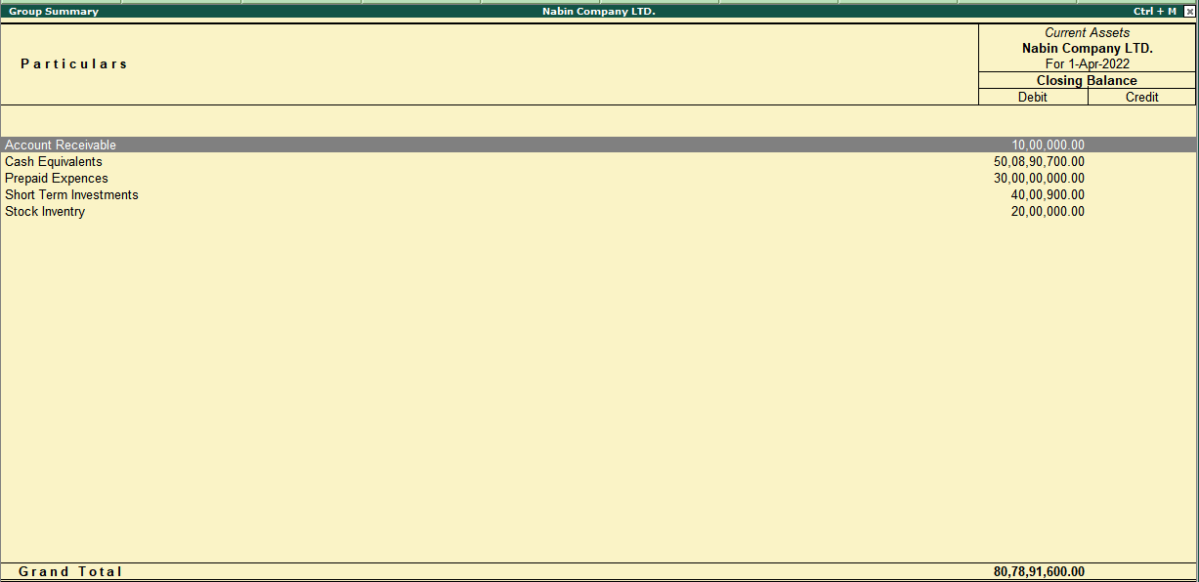

Posting on liabilities sides

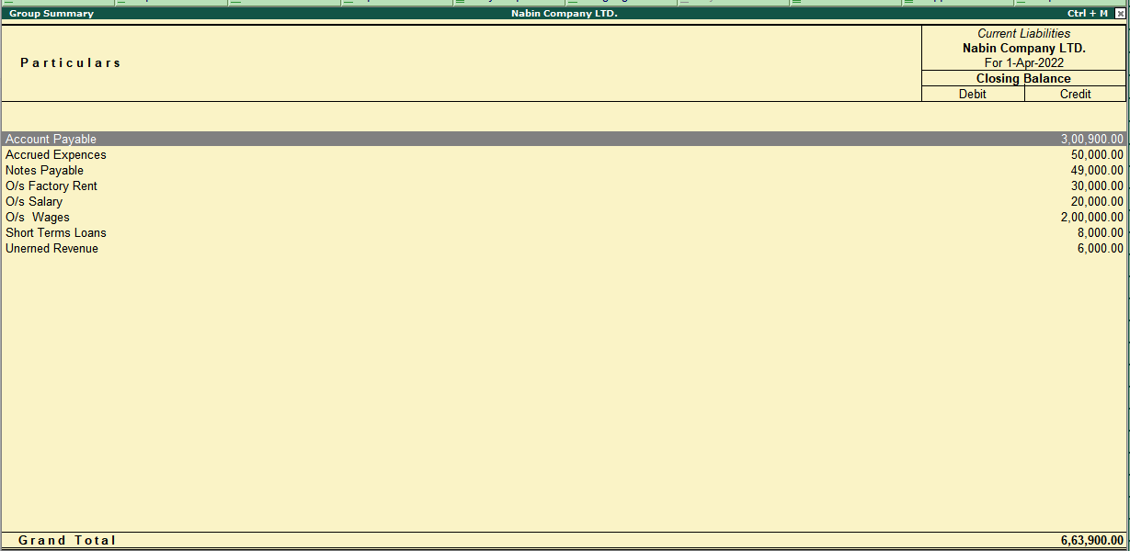

To go balance sheet click on the balance sheet option available in the gateway of Tally.

